Unidad académica/organismo que lo desarrolla: | Departamento de Teoría de las Artes
Horas de trabajo presencial y no presencial: | 3 horas presenciales.  1 horas no presenciales.
 | WEDNESDAY 15:30 a 18:00 on line
Número de Créditos SCT - Chile | X créditos.

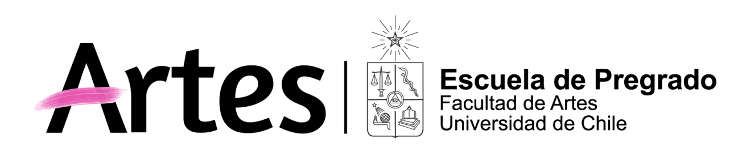
NOMBRE ACTIVIDAD CURRICULAR
History of Arte: Chilean Heritage (curso en ingles)

Historia de Chile: Patrimonio chileno

Propósito General del Curso
Familizar al alumno extranjero que entra vía movilidad estudiantil con la cultura chilena, nuestro patrimonio tanto tangible como intangible y las actividades que puede realizar en el área cultural durante su estadía en Chile. Como también es un curso donde alumnos chilenos pueden cultivarse más y practicar su inglés,

What’s it all about it:
This curse it is for international students who comes to do a semester in the Universidad de Chile. They will learn about our culture beg round and our heritage. We will speaker about art, literature, music from yesterday to today. Going us well to Museum and give you the information about activities in the city where you cut go. The course will be in English.

Competencias y Subcompetencias a las que contribuye el curso
Dar a conocer al alumno internacional y nacional el patrimonio nacional tanto tangible como intangible y familizarlo con el concepto de patrimonio
Objectives of this course:
The most important objective is to give to the international and national students more information about Chilean Heritage from the Precolonial Art, colonial time, the hay lights of art, the biggest interpretation we had….and then Chile today a new Chile. We will by toking about Art, Music cinema theater folklore
To understand better the world heritage first we are going to speak about heritage definition and the problems we have to day in Chile and in the world us clime change, traffic of art, falsification
The students will get a lot of information about pre-Columbian arte us we say Chile before Chile, Colonial time, Independencies from Spain and slowly the learn about Chilean heritage getting to the lust century and the time of today so the students will know at the end of the semester a lot of the different cultural indicatives.

Resultados de Aprendizaje
Dar conocimientos a los alumnos sobre nuestra cultura alumnos que generalmente son de otras carreras y del extranjero
What I would like
That you student from everywhere in the world have more information about Chile and his heritage that your stay in Chile is a happy one… as much as possible on me side

Saberes/Contenidos
Conceptos sobre patrimonio y los problemas que afrenta hoy día en Chile y el mundo clima turismo empatía. Como también tráfico ilícito, falsificaciones un gran negocio. La importancia del patrimonio tangible intangible tanto Chile como del mundo. El mundo de los museos la conservación restauración y el análisis científico
La cultura chilena desde el arte precolombinos hasta nuestros tiempos actuales tanto patrimonio tangible como intangible
What are the course speaking about?
First we will speak about Heritage what is heritage what problems we have today, Heritage in museum History of conservation and restoration and to day analysis of art giving the anther a lot of questions
We will speak with the Pre-Columbian art and music, Incas in Chile, Shaman and the Altiplano The deferent cultures Indian we had.in this long country.
Counting true colonial time, costumes, music and daily live, a little bit of history, the city of Santiago like the church and the museum of San Francisco
The independency of Chile from Spain and the time after that a long time with Isidora Zegers, in music and how we live in Santiago then. Lot of scientific investigators comes and also painters comes to Chile to paint to give classes make a more culturally live in Chile. Mulato Gil first the Rugenda, Gay and other artistic who let us pictures about the live in Chile.
Then we jump to the artistic you went to study in Paris XIX and XX and painters like Pedro Mira
We cannot forget de area of folklore so we will speak about Quasimodo la Tirana baile Chino and so on,
I will not forget Victor Jara, Violeta Parra
I thing we have a lot to speak in this course.
I would love to know more of the cultural beground, there countries of me students their cultures live so I can learn us well and all together we will make the course a live one

Metodología
Clases y conversaciones on line con apoyo de Power Points investigaciones a realizar
Methodology
Classes with Power points and active with music and so one it will by a dynamic course
You will make some investigation of other place involve in heritage

Evaluación
Trabajos de investigación sobre nuestra cultura
Evaluation
I will ask for 2 investigations about important things we will speak in classes. It will be elected between the teacher and the student. You will present them in the class on line and also send it to the mail of the teacher

Requisitos de Aprobación
Nota super a 4.0
You past the course when:
You must come to more than 80% of the classes on line and get notes better the 4.0 (Here in Chile the nots go from 1.0 very bed to 7,0 very good) in your investigation works

Palabras Clave

History of Arte: Chile culture and heritage see, hear and lessen de heritage of Chile

Bibliografía Obligatoria | Bibliografía Complementaria
Visit the Little history of Chile Sergio Villalobos  Oyendo a Chile S Claro  And biography I will be given in classes and send it to www. to www u.cusos  And  M  Oyendo  L | I

